Moodle And Odoo Integrating
Integrating Moodle with Odoo is absolutely possible via Moodle's Web Services API, particularly its REST API, which allows external apps (like Odoo) to push data such as users, courses, enrollments, etc.

Goal:
Send user data (e.g. name, age) to Moodle.
Create that user inside Moodle.

Tools Needed:
1. Moodle Web Service Token (for authentication).
2. Moodle REST endpoint: usually https://your-moodle-site.com/webservice/rest/server.php

3. A custom Odoo button on a model (e.g., res.partner or a custom student model).
4.A Python function in Odoo that sends the data to Moodle.

Integrating Guide
In Moodle :

- Enable Web Services (Site admin → Advanced features).
- Create a new external service.
- Add functions like core_user_create_users.
- Create a token for a specific user with appropriate permissions

🧪 Sample Moodle JSON Output (Success):

🧨 On Error (Example):
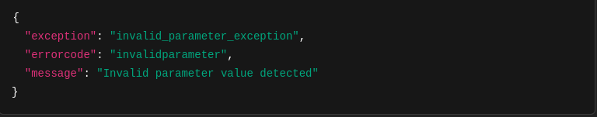

https://www.youtube.com/watch?v=Ud139zt2s8c<==== Ref:
site administration ==> server ==> web services ==> overviews

Create api user (should be admin )==> email need
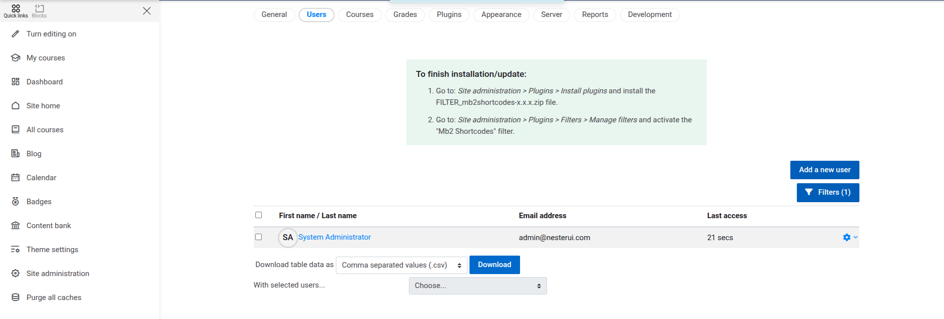
Site admission ==> (server) Web services ==> Overview
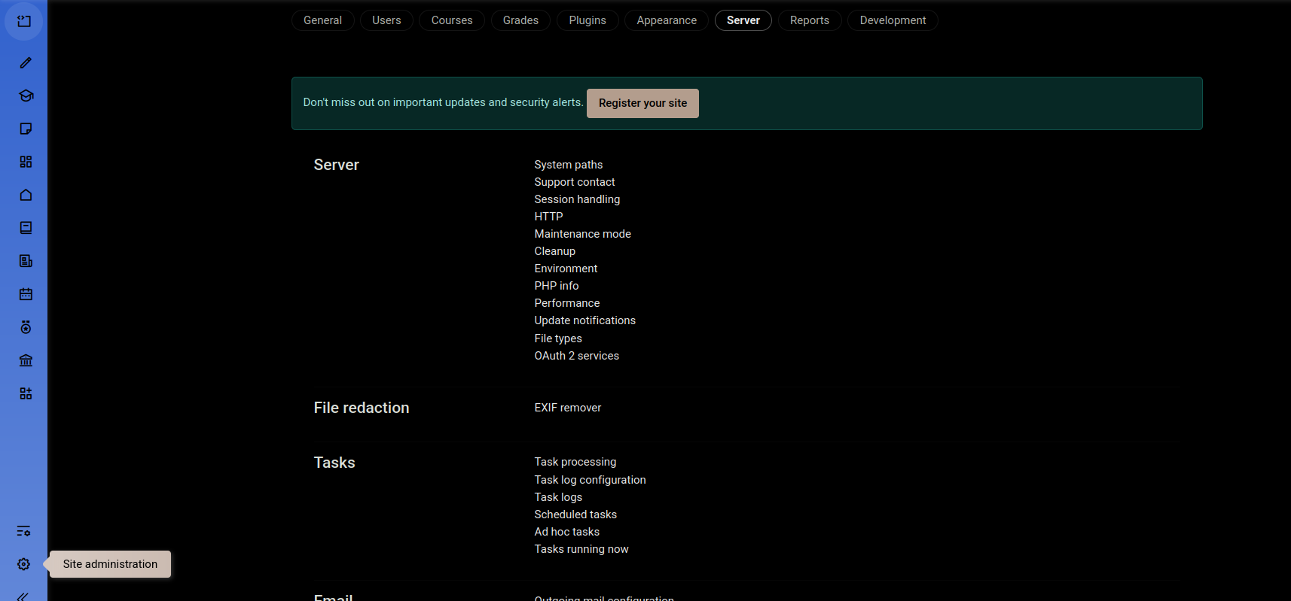
Enter Overview( view No , None)
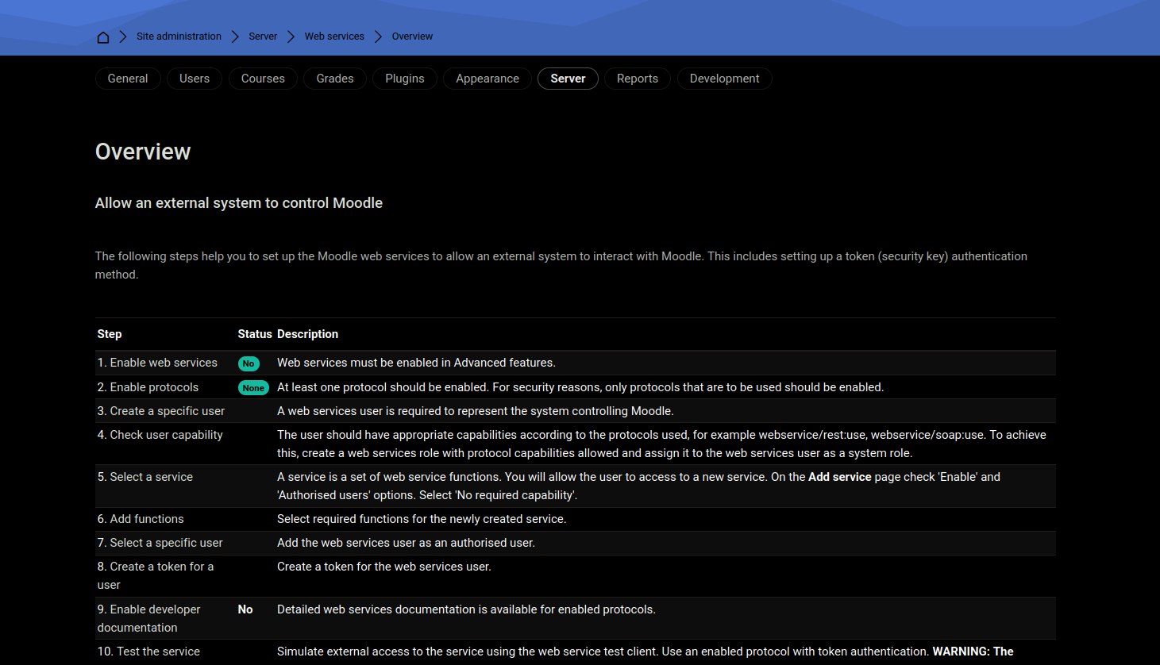

Check Enable Web Service

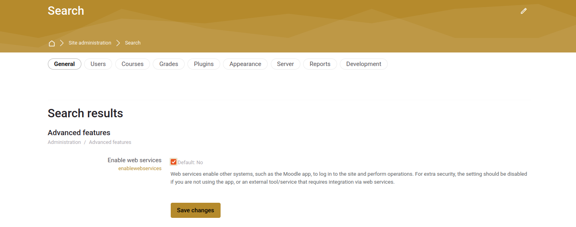
And REST protocol ( for using REST API )

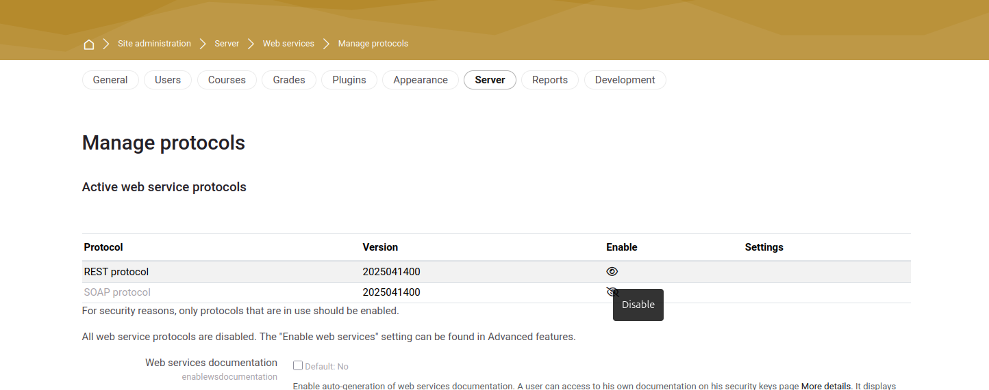

Add New Service= server =>Web Services => External Services(ADD Custom Services)
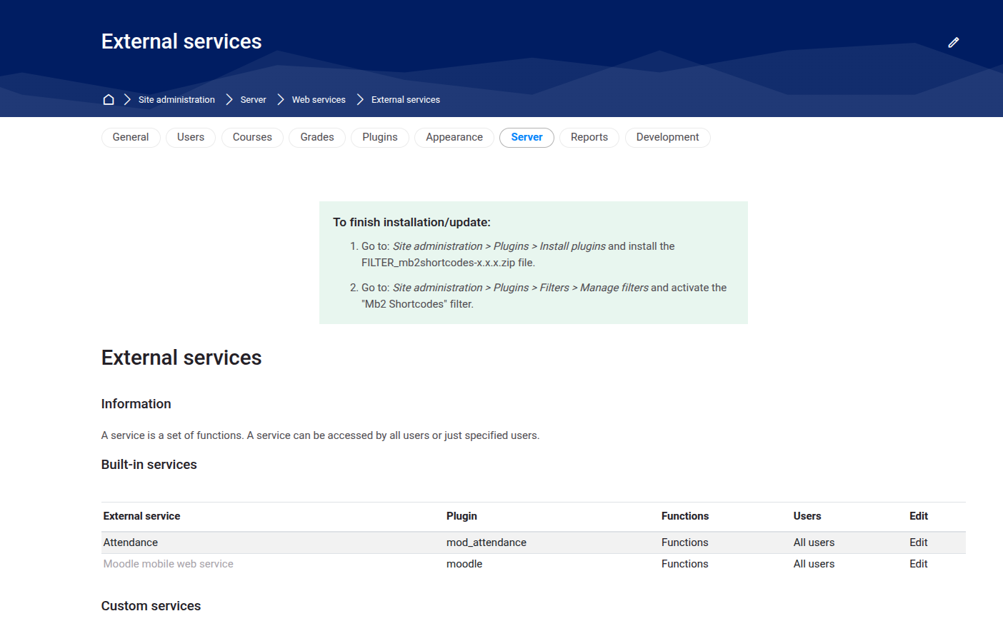
Add Custom Functions for this Custom Services
In This Function the core_webservice_get_site_info function is added to the web service that the token is linked to.
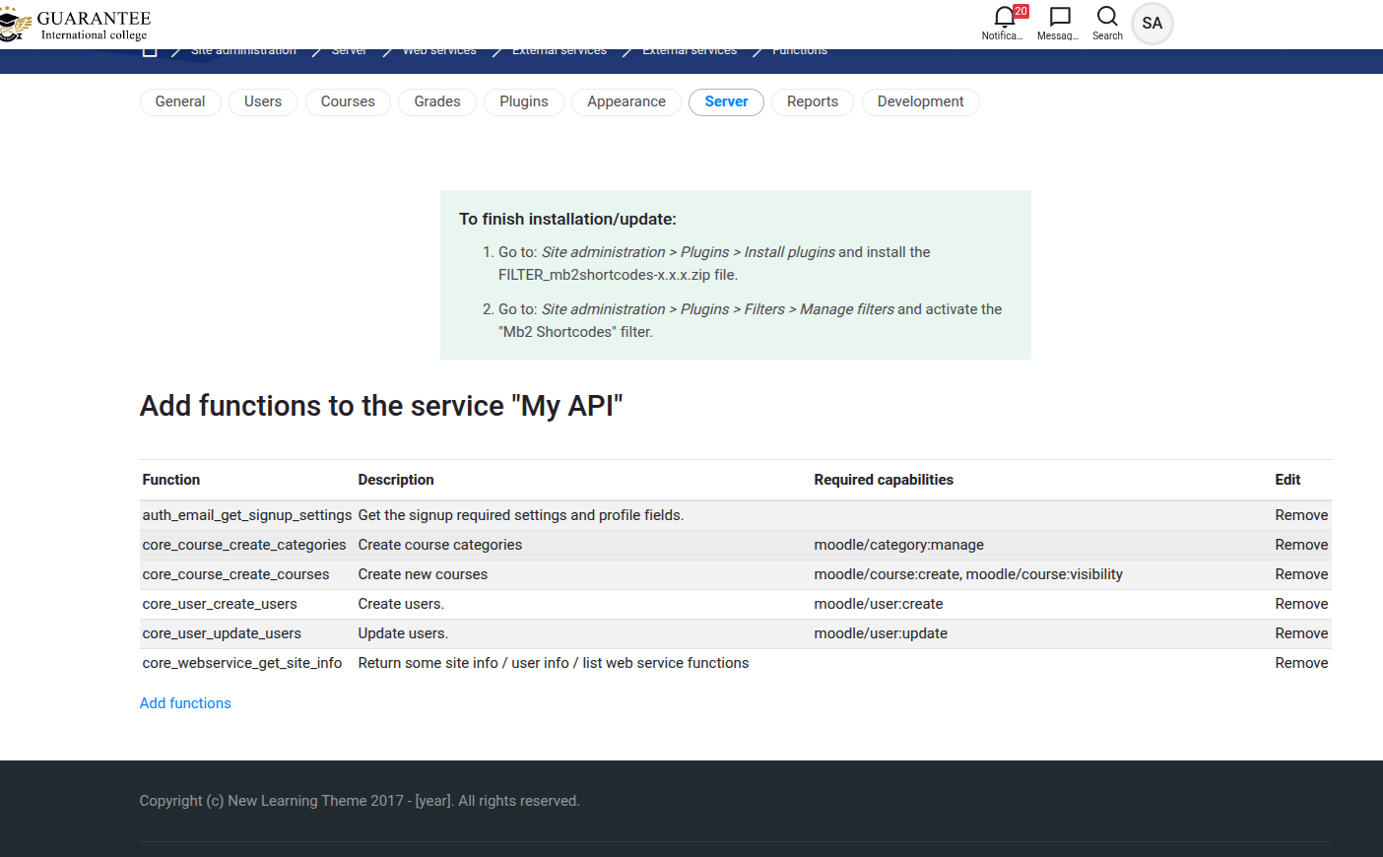

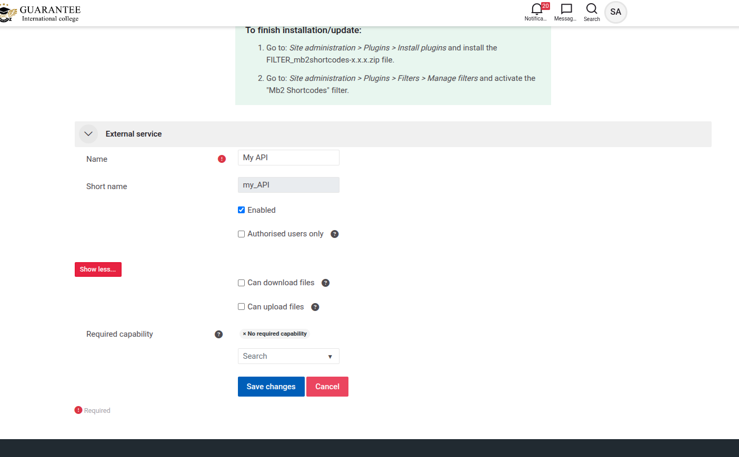

Create Token For Specific User
In This state careful service is myApi Service should be
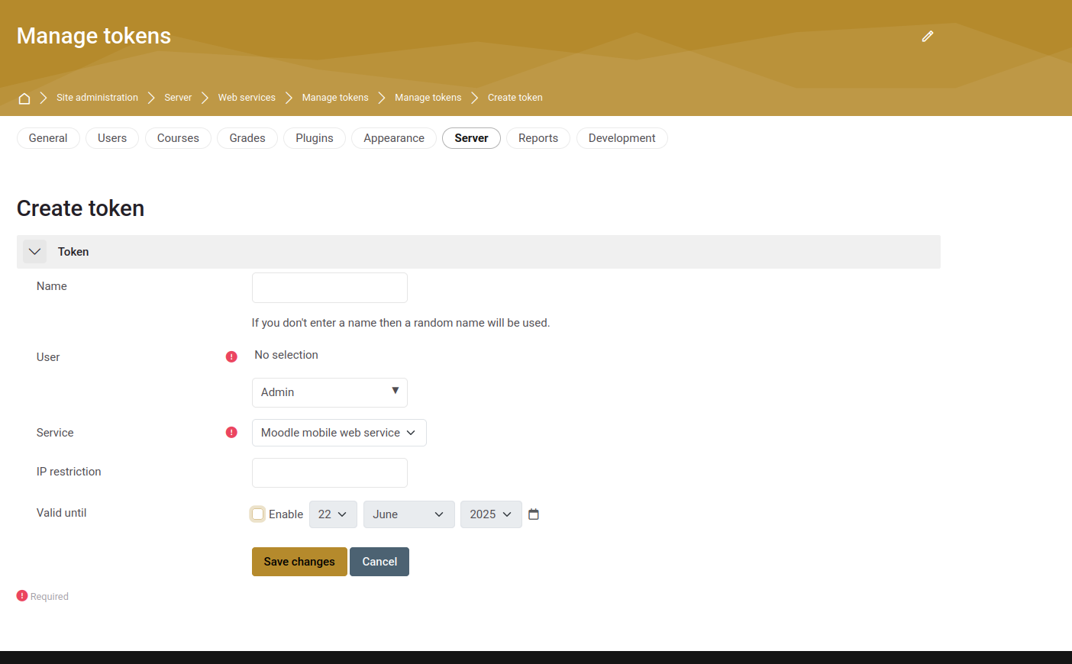

Define Site Admission for specific user (should related to myAPi)
and Enable Developer Documentation(check this) check box
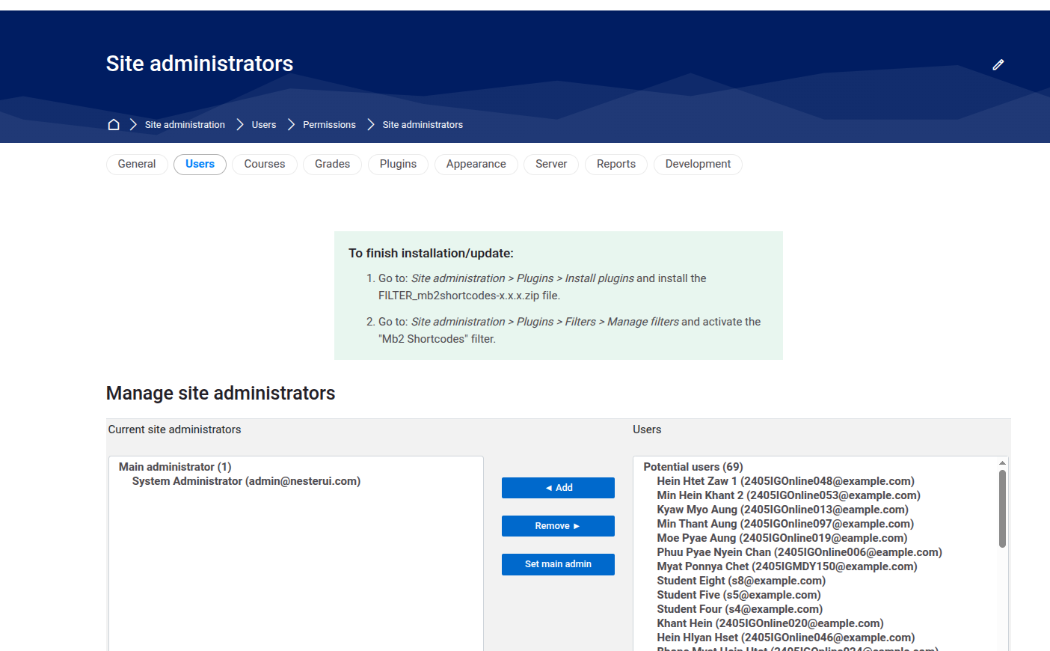

Manage Auth==>Go to the Plugins=> Authentication(Manage Authentication)=> Web service Authentication to enable
